

**Artificial Intelligence and Data Science Department.**

OOPM / Odd Sem 2021-22 / Experiment 13.

**____________________________________________________________**

YASH SARANG.

47 / D6AD.

EXPERIMENT - 13.

**____________________________________________________________**

**AIM / THEORY:** 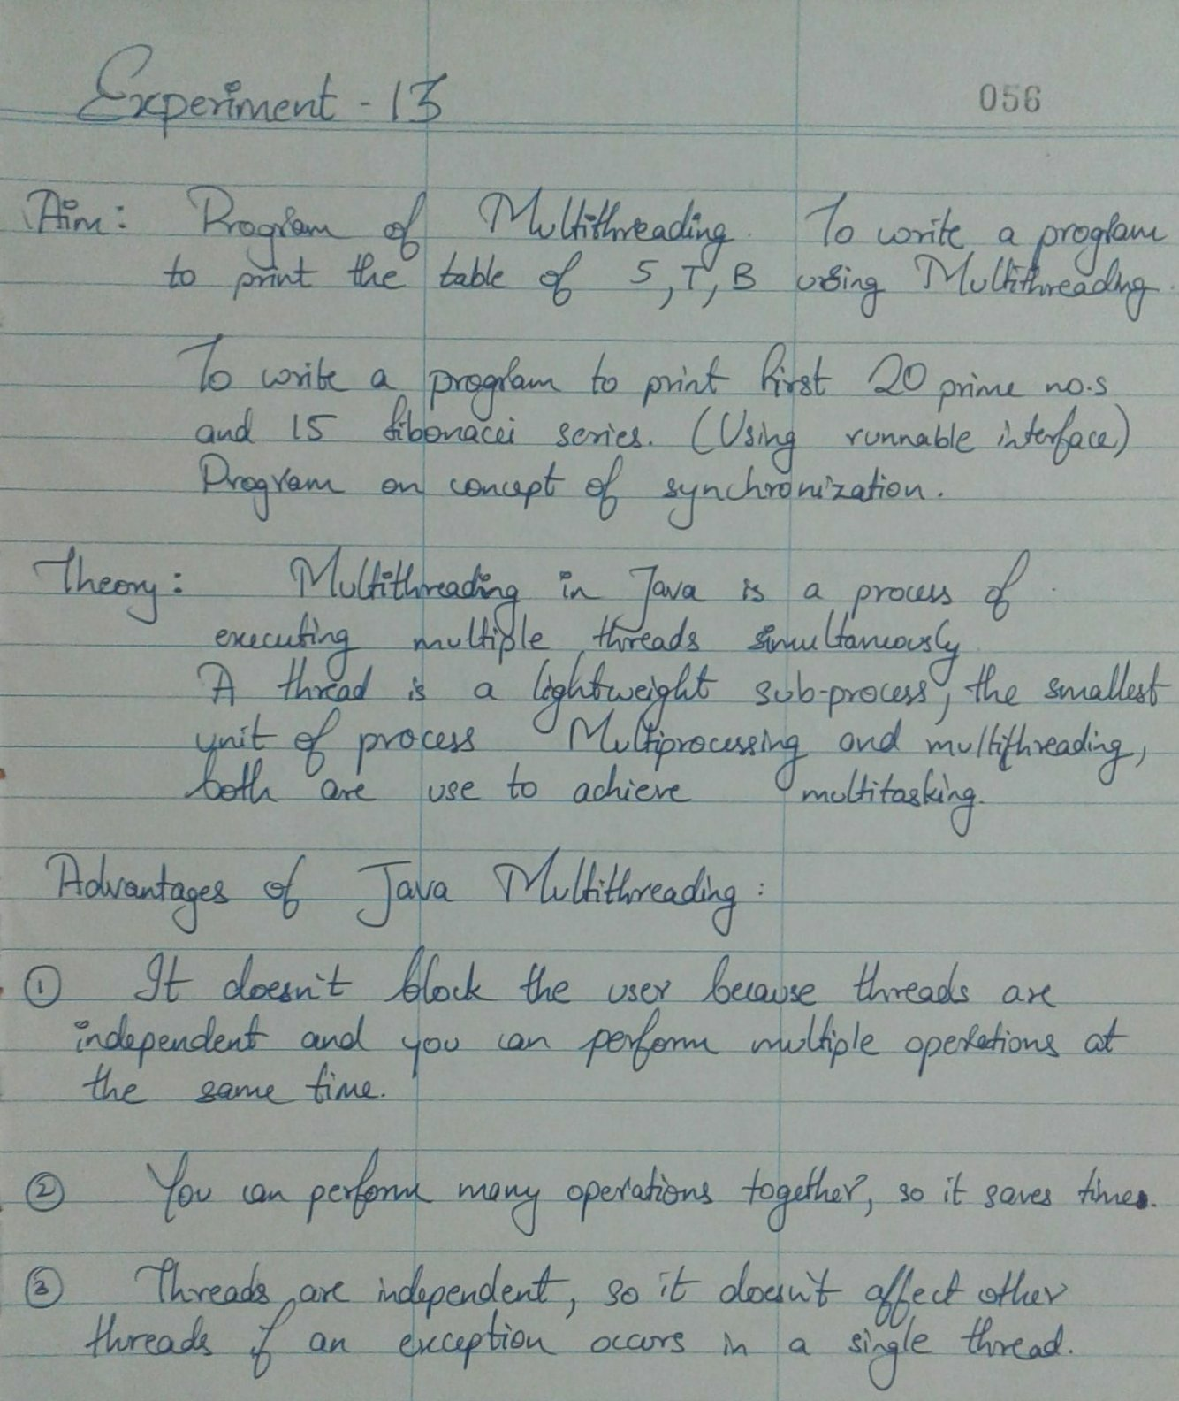

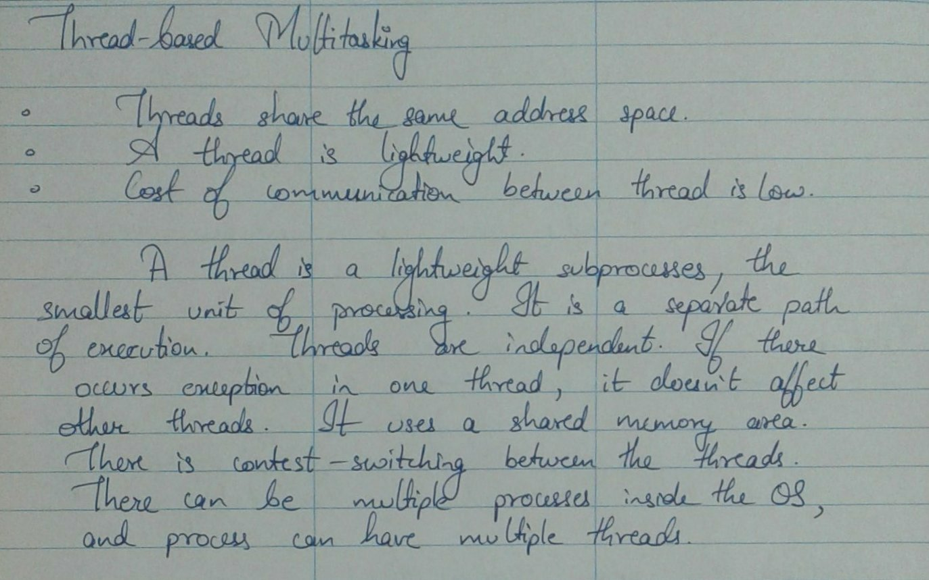

**____________________________________________________________**

**Program Code**:

*import java.lang.Runnable;*

*import java.util.Scanner;*

*class MultiThreading*

*{*

*public static void main(String args[])*

*{*

*System.out.println("Hello");*

*Prime a = new Prime();*

*Fibonnaci b = new Fibonnaci();*

*Thread c = new Thread(b);*

*//start Prime thread*

*a.start();*

*try*

*{*

*//wait for prime a to stop execution*

*a.join();*

*}*

*catch( InterruptedException e)*

*{*

*System.out.println("ERROR : " + e);*

*}*

*//start Fibonacci thread*

*c.start();*

*}*

*}*

*class Prime extends Thread*

*{*

*public void run()*

*{*

*System.out.println("In Prime class");*

*Scanner in = new Scanner(System.in);*

*System.out.print("Enter Count : ");*

*int count = in.nextInt();*

*int status = 1;*

*int num = 3;*

*if (count >= 1)*

*{*

*System.out.println("First "+count+" prime numbers are:");*

*System.out.println(2);*

*}*

*for ( int i = 2 ; i <=count ; )*

*{*

*for ( int j = 2 ; j <= Math.sqrt(num) ; j++ )*

*{*

*if ( num%j == 0 )*

*{*

*status = 0;*

*break;*

*}*

*}*

*if ( status != 0 )*

*{*

*System.out.println(num);*

*i++;*

*}*

*status = 1;*

*num++;*

*}*

*System.out.println("Prime thread finished! ");*

*}*

*}*

*class Fibonnaci implements Runnable*

*{*

*public void run()*

*{*

*System.out.println("In Fibonnaci class");*

*int a,b,c;*

*a = 0; b = 1;*

*Scanner in = new Scanner(System.in);*

*System.out.print("Enter Count : ");*

*int count = in.nextInt();*

*if( count == 1)*

*{*

*System.out.println("FIBO SERIES : " + a);*

*return;*

*}*

*else*

*{*

*System.out.println("FIBO SERIES : " + a);*

*System.out.println("FIBO SERIES : " + b);*

*for(int j = 0; j<count; j++)*

*{*

*c = a+b;*

*System.out.println("FIBO SERIES : " + c);*

*a = b;*

*b = c;*

*}*

*}*

*System.out.println("Fibonacci Thread finished!");*

*}*

*}*

**____________________________________________________________**

**Output:**

*Hello*

*In Prime class*

*Enter Count : 12*

*First 12 prime numbers are:*

*2*

*3*

*5*

*7*

*11*

*13*

*17*

*19*

*23*

*29*

*31*

*37*

*Prime thread finished!*

*In Fibonnaci class*

*Enter Count :*

**____________________________________________________________**

**Program Code:**

*class javasync*

*{*

*public static void main(String args[])*

*{*

*Table obj = new Table();*

*Tableof5 a = new Tableof5(obj);*

*Tableof10 b = new Tableof10(obj);*

*a.start();*

*b.start();*

*}*

*}*

*class Table*

*{*

*synchronized void printTable(int n)*

*{*

*for(int i = 1; i<=5 ; i++)*

*{*

*System.out.println(n*i);*

*}*

*try*

*{*

*Thread.sleep(500);*

*}*

*catch(Exception e)*

*{*

*System.out.println("ERROR : "+e);*

*}*

*}*

*}*

*class Tableof5 extends Thread*

*{*

*Table t;*

*Tableof5(Table t)*

*{*

*this.t = t;*

*}*

*public void run()*

*{*

*t.printTable(5);*

*}*

*}*

*class Tableof10 extends Thread*

*{*

*Table t;*

*Tableof10(Table t)*

*{*

*this.t = t;*

*}*

*public void run()*

*{*

*t.printTable(10);*

*}*

*}*

**____________________________________________________________**

**Output:**



